# Project: Analyzing a Market Test

Complete each section. When you are ready, save your file as a PDF document and submit it [here](https://classroom.udacity.com/nanodegrees/nd008/parts/11a7bf4c-2b69-47f3-9aec-108ce847f855/project).

## Step 1: Plan Your Analysis

*To perform the correct analysis, you will need to prepare a data set. (500 word limit)*

*Answer the following questions to help you plan out your analysis:*

1. What is the performance metric you’ll use to evaluate the results of your test?

Round Roasters, a coffee restaurant in the United States of America, conducted a market test with a new menu and needs to figure whether the new menu can drive enough sales to offset the cost of marketing the new menu. This project is to analyze the A/B test and write up a recommendation to whether the Round Roasters chain should launch this new menu.

1. What is the test period?

Testing of the new menu lasted 12 weeks from 2016-04-29 through to 2016-07-21.

For the analysis, trend and seasonality will need to be calculated for matching of control and treatment units. This process requires 52 weeks of historical data plus another 6 periods of data on top. Since the testing was done over a 12 week period, each period being 1 week, the total number of weeks needed for analysis is below:

|  |  |
| --- | --- |
| Item | Period |
| Historical Analysis | 52 weeks |
| Trend Analysis | 6 weeks |
| Testing | 12 weeks |
| Total | 70 weeks |

This means start date for the data needed is 2015-03-20 through to 2016-07-21.

1. At what level (day, week, month, etc.) should the data be aggregated?

The transaction data for Round Roasters Stores will need to be filtered for the above-mentioned periods. The remaining data will need to be aggregated by the following:

|  |
| --- |
| Weekly period |
| Invoices as an indication of store traffic |
| Store ID |
| Gross Margin |
| Sales |

## Step 2: Clean Up Your Data

*In this step, you should prepare the data for steps 3 and 4. You should aggregate the transaction data to the appropriate level and filter on the appropriate data ranges. You can assume that there is no missing, incomplete, duplicate, or dirty data. You’re ready to move on to the next step when you have weekly transaction data for all stores.*

Both gross margin and customer traffic (distinct invoices) were aggregated to a week level. To avoid skewing the analysis, only stores with 76 weeks of data were retained in the analysis to calculate trend and seasonality.

## Step 3: Match Treatment and Control Units

*In this step, you should create the trend and seasonality variables, and use them along with you other control variable(s) to match two control units to each treatment unit. Note: Calculate the number of transactions per store per week to calculate trend and seasonality.*

*Apart from trend and seasonality...*

1. What control variables should be considered? Note: Only consider variables in the RoundRoastersStore file.

AvgMonthSales should be considered as constant variables while Square Feet should be ignored.

1. What is the correlation between each potential control variable and your performance metric?

From the Pearson Correlation Analysis, AvgMonthSales has high correlation of 0.79 with the performance metric, i.e. Sum of Gross Margin. On the other hand, Square Feet has a poor correlation of -0.046.



1. What control variables will you use to match treatment and control stores?

AvgMonthSales will be used together with Trend and Seasonality when matching treatment and control stores.

1. Please fill out the table below with your treatment and control stores pairs:

|  |  |  |
| --- | --- | --- |
| Treatment Store | Control Store 1 | Control Store 2 |
| 1664 | 1964 | 8562 |
| 1675 | 1807 | 7584 |
| 1696 | 1863 | 7334 |
| 1700 | 7037 | 1508 |
| 1712 | 8162 | 7434 |
| 2288 | 2568 | 9081 |
| 2293 | 12219 | 9639 |
| 2301 | 11668 | 12019 |
| 2322 | 9238 | 9388 |
| 2241 | 2572 | 3102 |

## Step 4: Analysis and Writeup

*Conduct your A/B analysis and create a short report outlining your results and recommendations. (250 words limit)*

*Answer these questions. Be sure to include visualizations from your analysis:*

1. What is your recommendation - Should the company roll out the updated menu to all stores?

This analysis assessed the commercial viability of launching a new menu. The analysis overall demonstrated a significant lift of 39.6% in weekly gross sales across the ten stores (p<0.001) (fig 1). This exceeds the required threshold set by management to risk the additional investment required to launch the new menu across all stores. As such, the new menu should be introduced nationwide.

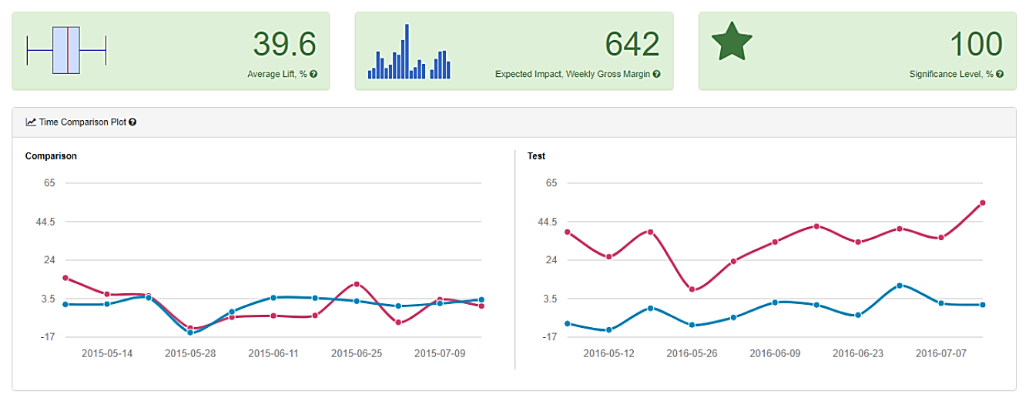

Fig. 2: Summary of findings for both regions.

1. What is the lift from the new menu for West and Central regions (include statistical significance)?

When examining the results by region, similar results were identified. In the West region the new menu resulted in a significant lift of 38.1% in weekly gross margin [$509.1] (p=0.007). When compared to the same weeks in the preceding year, the control group remained largely unchanged while the treatment group demonstrated a substantial increase in gross margin (fig 2).

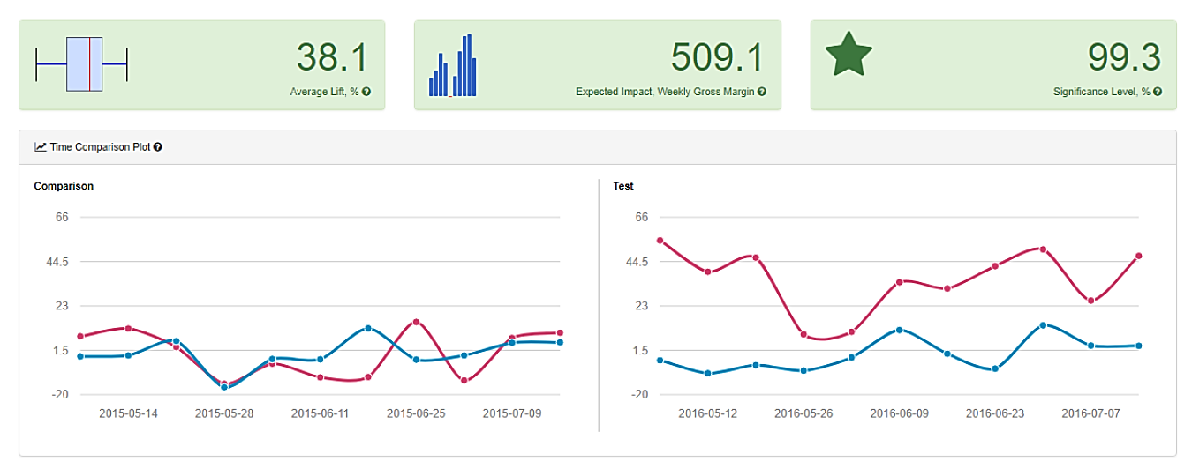

Fig. 2: Summary of findings West Region

In the central region, the new menu also resulted in a significant lift of 41.1% in weekly gross margin (p=0.008). Like the West region, the treatment stores in the Central region demonstrated a substantial increase in gross margin for each week in comparison to the same period in the preceding year. In contrast, the control stores generally remained unchanged (fig 3). This would equate to an expected increase of $774.8 per store per week.

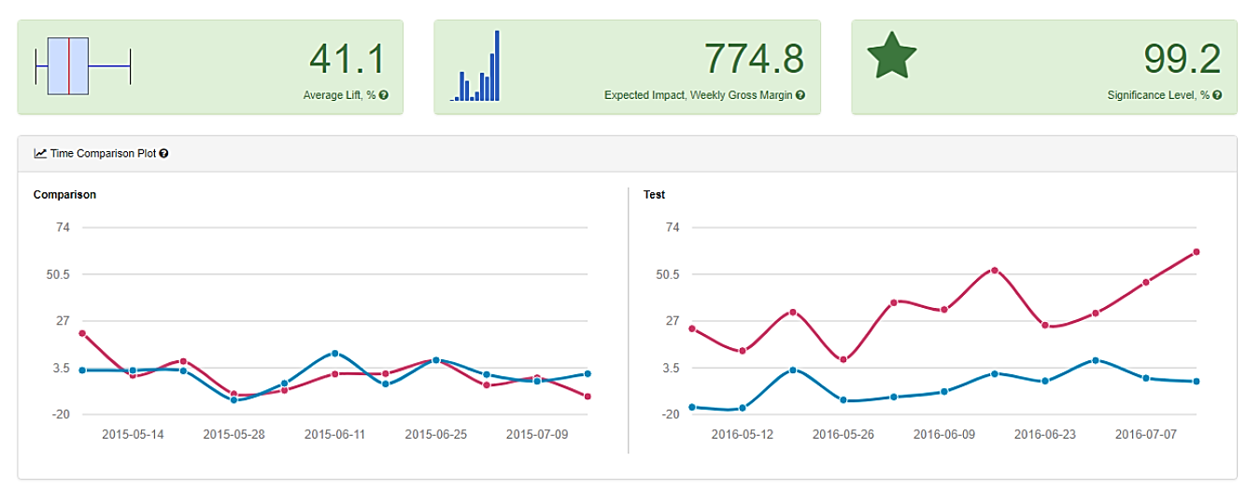

Fig 3: Summary of findings for west region.

1. What is the lift from the new menu overall?

In conclusion, I would recommend Round Roasters implement the new menu to all stores due to a lift of 39.6%. Given these positive findings, the introduction of this menu across all stores can be recommended.

## Alteryx Workflows

## 

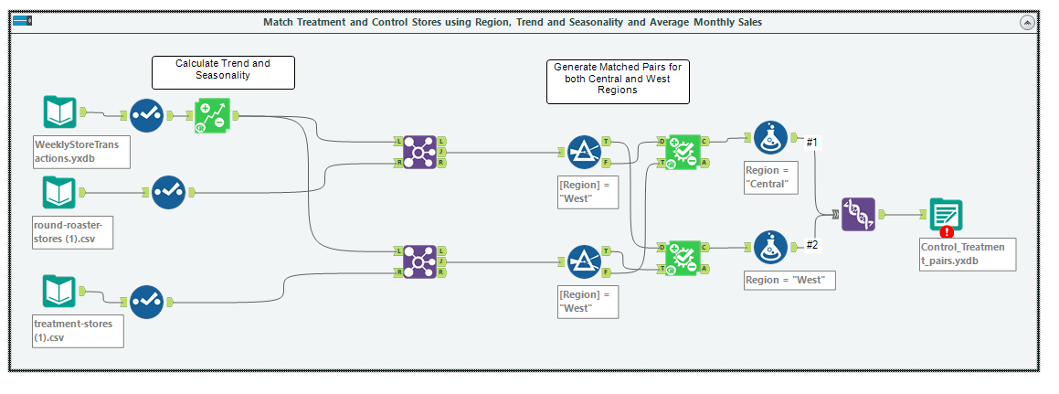

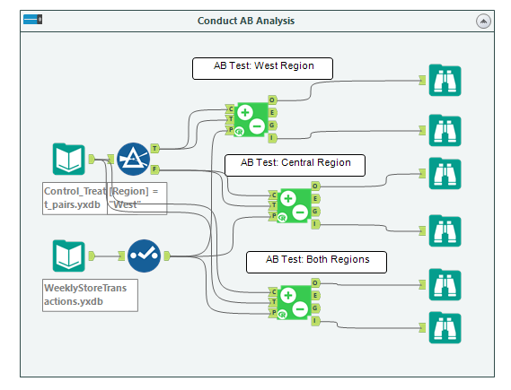

## Before you Submit

Please check your answers against the requirements of the project dictated by the [rubric](https://review.udacity.com/#!/rubrics/287/view) here. Reviewers will use this rubric to grade your project.